Form extention in caDSR Domian model

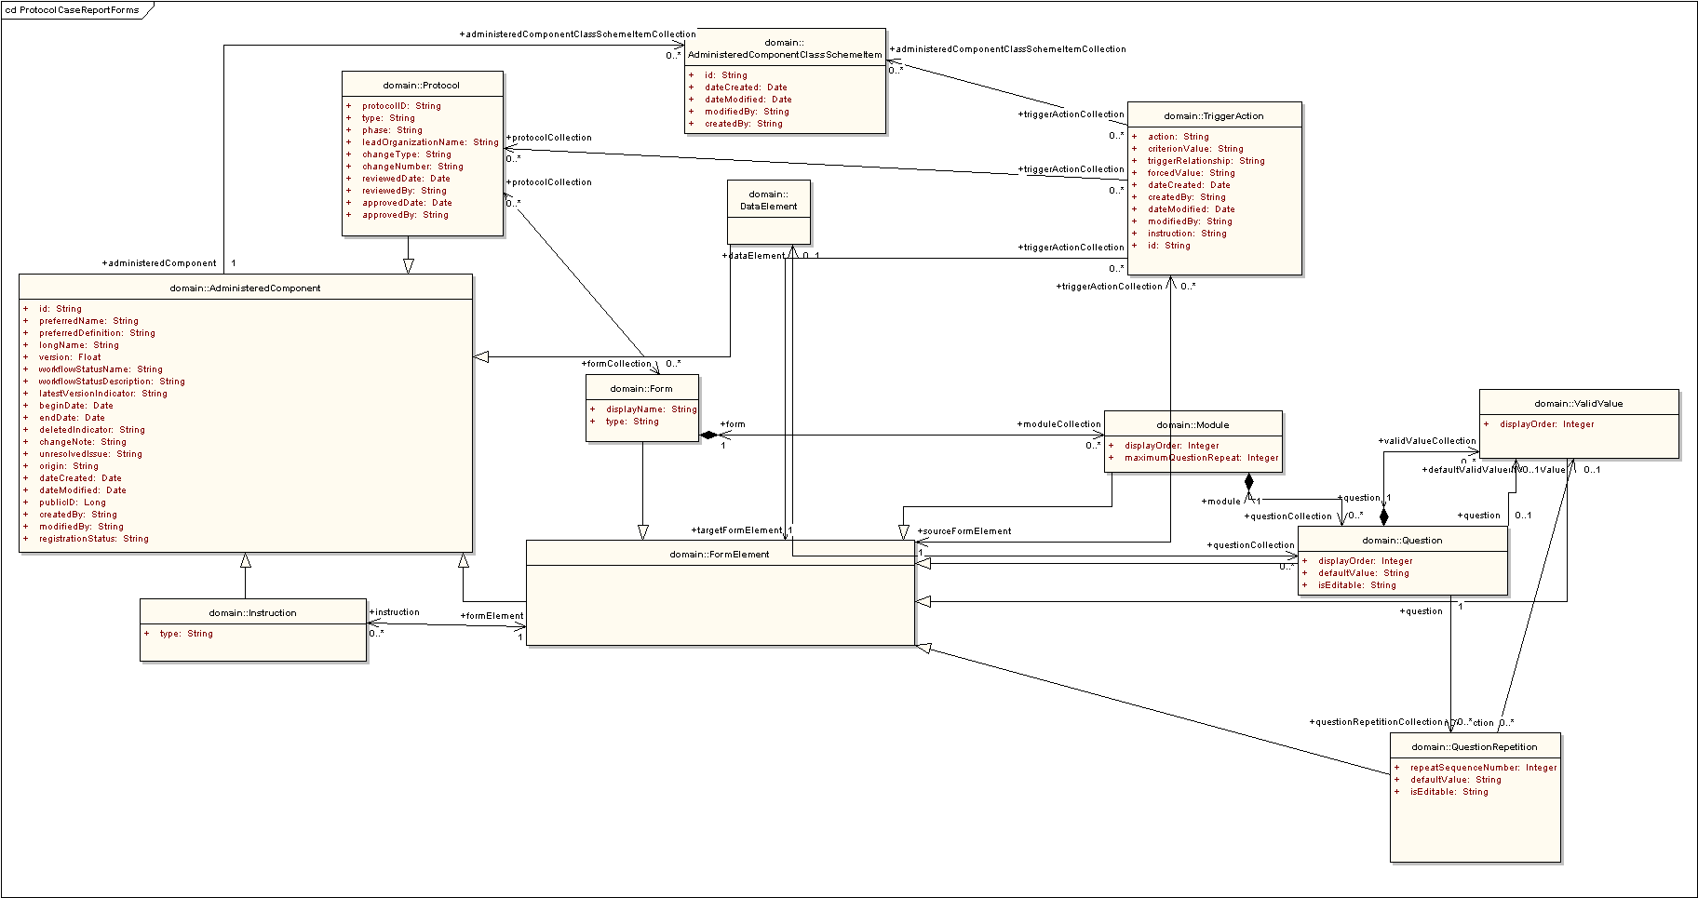

Protocols
Protocol is Collection of forms, A form can associated with multiple forms

Form Element
This class represents all elements that could be placed within a form including the form itself. This class inherits from administered components. A FormElement can have instructions which extends from administered component.

Subclass: Form, Module, Question, ValidValue, QuestionRepitition

Form
Form is collection of Modules. A form’s Type attributes defines the type of form which currently is limited to CRF and Template

Module
Module is a Collection of Questions.

Question
Question on a form, Question can be associated with CDE. Question can have either default value or default valid value.

Valid Value
Valid Value for a Question

QuestionRepetition
This Class represents the repetition of a question within a Module. A Module can repeat many times and is defined by the attribute maximunQuestionRepeat. Question in each repetition of a module can have its own default value, which is defined in QuestionRepetition for that Question. RepeatSequenceNumber attribute defines to which module repetition sequence the QuestionRepetition belongs. QuestionRepetitions are assigned to a Question only if the repetition of that Question has a default(value/ValidValue) or Other QuestionRepetition Specific Attributes

TriggerAction
This Class holds information about an action (jump to) from one location on a form to another location on a form. Any Form Element can have many trigger actions. Trigger Action can be associated with a set of Protocols or Classifications.

